ServiMapp – Diagramas de Clases (Arquitectura Hexagonal)
Fecha: 26/12/2025
Iteración CD-4 (v1.0). Alcance: ads-service, certificates-service, tracking-service.

1. ads-service
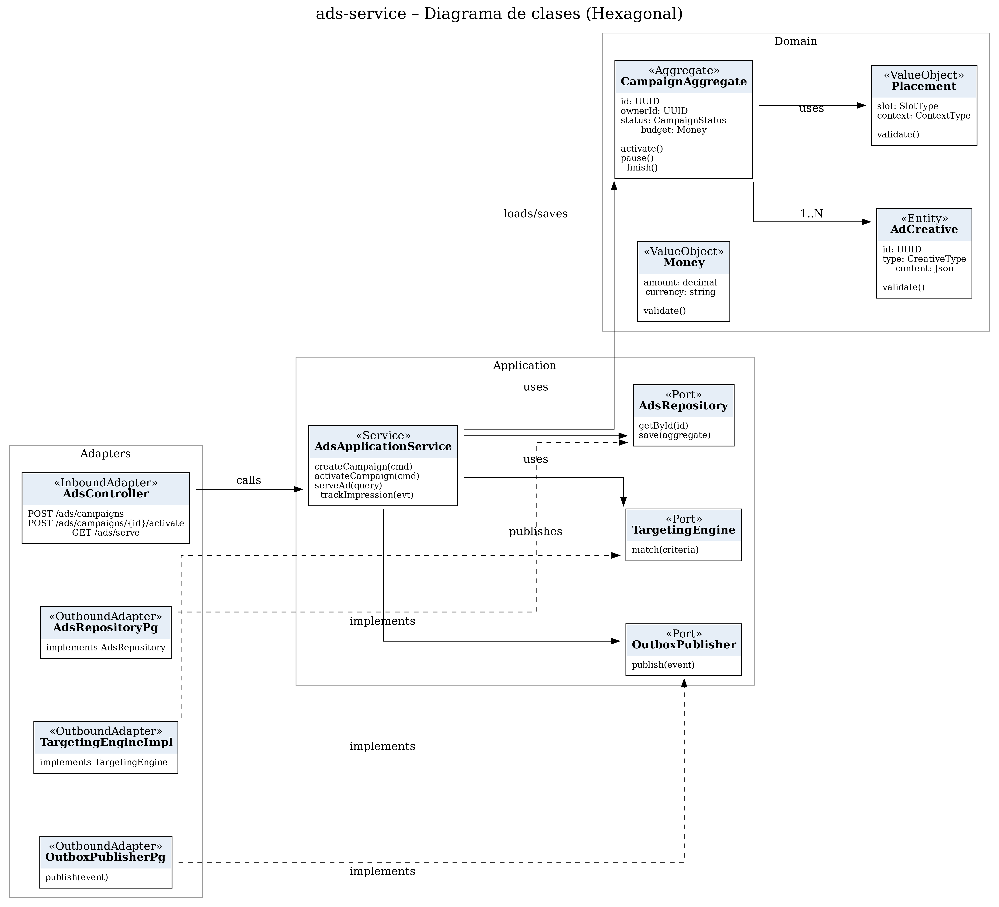

2. certificates-service
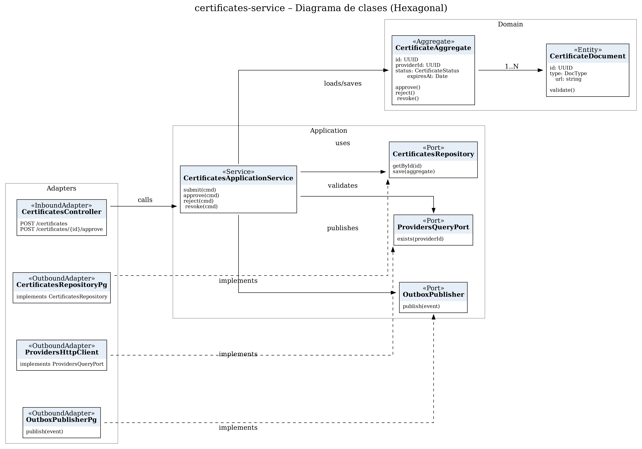

3. tracking-service
